COURSE SYLLABUS

Course: GEB 3213 Business Writing and Communication
Campus: Valencia West
Semester/Term: Spring 2021
Prerequisites: ENC1101 or ENC1101C with a grade of “C” or better
Credit Hours: 3
Class Meeting Day/Time:
Classroom: Online

Professor: David Lynch, MBA
Email: Dlynch7@valenciacollege.edu
Office Hours: Zoom or Phone Call by Appointment
Best Mode of Contact: Canvas Email

Course Description:
This course is a study of the basics of business writing and introduces students to common formats, such as the memo, letter, and report. The course will stress techniques to improve writing skills and will teach students how to apply techniques used in the business writing process. Other topics covered include, but are not limited to, appropriate strategies for internal and external communication situations, audience analysis, and communication through technology.

Course Major Learning Outcomes:
Students will be able to:
- Demonstrate proficiency in grammar, punctuation, capitalization, and word use.
- Determine how the various forms of business communication affects business outcomes.
- Understand and discuss the importance of communication processes and skills, critical thinking, and ethics in an increasingly digital workplace.
- Draft business documents, including visual aids, that are grammatically correct and in the appropriate business style.
- Draft a research report that effectively communicates its purpose to its audience using effective, organization, development, and style.
- Identify and develop appropriate materials for the employment search process.
Required Text:
The Open Educational Resources (OER) used for the duration of this course (No Textbook Fee):
Business Communication for Success: Open Educational Resources Textbook

(Hold CTRL+ Click Link): Also Available on Your Canvas Homepage

Course Organization:
This course will be divided into four categories that will comprise the final grade.

Discussion 20%
Exercises 25%
Exams/Quizzes 30%
Program Portfolio Project 25%
100%

General Grading Scale:
A: 90-100
B: 80-89
C: 70-79
D: 60-69
F: 60-below

CLASSROOM POLICIES

Attendance, Assignments and Grading Information
Schedule and Deadlines. You may view the assignment schedule, along with assignment deadlines, on our course schedule and webpage through Canvas. We will learn how to navigate this site as a class within our first few class meetings. You can familiarize yourself with Canvas. Course assignments will be checked for plagiarism using the "Uni-Check" Plagiarism software, which is embedded into each assignment. All forms of academic dishonesty are prohibited at Valencia College. Academic dishonesty includes, but is not limited to, acts or attempted acts of plagiarism, cheating, furnishing false information, forgery, alteration or misuse of documents, misconduct during a testing situation, facilitating academic dishonesty, and misuse of identification with intent to defraud or deceive. For more information on Academic Dishonestly Click Here: Valencia College Academic Dishonesty Policy

Discussion Instructions (Initial Post is Require before “Viewing” Peer Posts): You are required to submit a substantial response. A substantial response is one that stays on topic and fully addresses the assignment in a clear, concise, and meaningful manner. Substantial Content refers to providing relevant content toward the actual topic of the discussions. This includes quality input, questions and information in your discussion posts and responses to peers.
The deliverable length of initial posting must be at least 150 words. After the initial posting, students are required to respond to at least two (2) peers’ responses. Peer responses must be at least 50 words for each response, to receive full credit. Discussions must be the student’s original thoughts based on the topics from the "Open Educational Resource" (OER)Course Textbook and/or other referenced sources. Direct quotes from references must be less than 10 words. Please review postings for sentence structure, grammar, and punctuation errors.
Plagiarized discussions will result in a "0" for the submission of this assignment.
Late submissions are not accepted for discussions.
All assignment(s) derive from the OER Textbook. For academic purposes, at least 1 APA formatted reference is required pertaining to the topic(s).
Discussion Posting Rules
- Personal attacks of other students because of their posts will not be tolerated.
- Provide clear analysis and insight into the topic or questions.
- Post original thoughts to avoid plagiarism and the penalties for plagiarism
- Zero or minimal credit will be given to students with very FEW or NO SUBSTANTIVE postings or who post all posts within a matter of minutes or all on the last day.
- Proof postings to eliminate offensive references, poor sentence syntax, misspelled words, etc.
Exercise Instructions: You are required to submit a 2-Page (Title Page and Content Page), APA formatted paper with substantial content. Substantial content requires staying on topic and fully addresses the assignment in a clear, concise, and meaningful manner. The deliverable length of your posting responses must be at least 2-pages, (Title Page and Content Page) APA format. Please review your paper for grammar and punctuation errors.
Exercises must be the student’s original thoughts based on the topics from the "Open Educational Resource" (OER) Course Textbook and/or other referenced sources. Direct quotes from references must be less than 20 words. Plagiarized exercises may result in a "0" for the submission of this assignment. Please review postings for sentence structure, grammar, and punctuation errors.
Late submissions will be deducted 5 points.
All assignment(s) derive from the OER Textbook. For academic purposes, at least 3 APA formatted reference is required pertaining to the topic(s).
Exam Instructions: Mid-Term/Final Exam contains “critical thinking” randomly selected essay questions. Students will be instructed in and will apply critical thinking skills to include creative thinking, innovation, inquiry, analysis, evaluation, and synthesis of information. Students will be instructed in and will apply knowledge, skills, and ability to include development, interpretation, and expression of ideas through written communication.
Students will have 1 attempt to complete the exam (no time limit). Students must complete the entire exam in the attempt (If the exam or the web browsers is closed - the exam is considered completed).The exam consists of 10 randomly selected essay questions based on the related chapter(s) learning objectives of each module covered thus far.
Students are required to read and fully answer the essay questions to receive full points. Students are required to submit substantial responses to each essay question. A substantial response is one that stays on topic and fully addresses the essay question in a clear, concise, and meaningful manner. Some essay questions required the student to provide examples to support the essay question being answered. The deliverable length of answer must be at least 150 words. Please review your answers for grammar and punctuation errors.
All exam questions derive from the OER Textbook. Each essay question must include at least 1 APA formatted reference(s) from the OER Textbook.
Program Portfolio (Capstone) Project - Course GEB 3213: Develop a basic portfolio business organization description. Develop and create an introduction to the business you will be using for the duration of the Program Portfolio Project. Use Research examples to support the development of your Program Portfolio Project introduction and overall format. Please follow the Business Portfolio Outline. In the event that you do not, a 20 point deduction will automatically be given.
You are required to submit a 3-Page (Title Page and 2 Pages of Content), APA formatted paper with substantial content. Substantial content requires staying on topic and fully addresses the assignment in a clear, concise, and meaningful manner. The deliverable length of your posting responses must be at least 3-page (Title Page and 2 Pages of Content), APA format. Please review your paper for grammar and punctuation errors.
Submission must be the student's original thoughts based on the topics from the "Open Educational Resource" (OER) Course Textbook and/or other referenced sources. Direct quotes from references must be less than 20 words. Plagiarized submissions may result in a "0" for the submission of this assignment. Please review for sentence structure, grammar, and punctuation errors.
Late submissions will be deducted 10 points.
For academic purposes, at least 3 APA formatted reference is required pertaining to the topic(s).

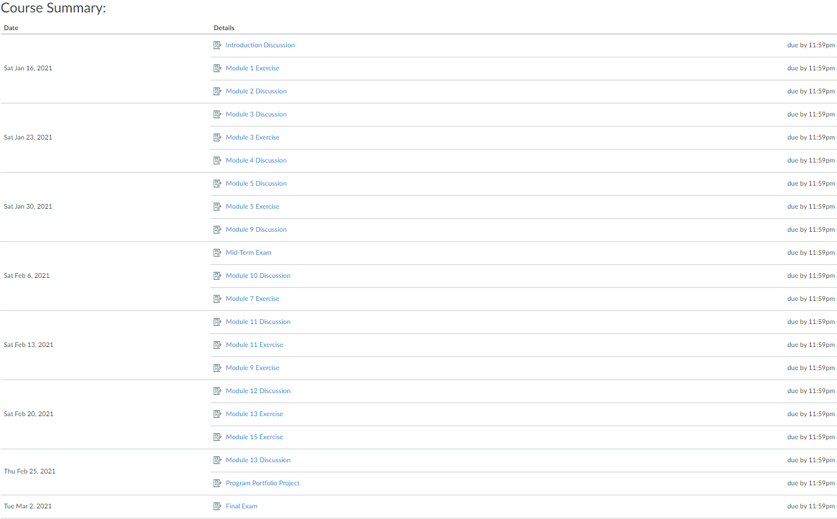

Make-up Exams:
Make-up exams will only be given in emergency situations provided the instructor is notified in advance (prior to the absence). Upon approval of your absence, the exam will be placed in the testing center. Exams must be made up before the next class meeting. Any test missed will have an adverse effect on your grade, and make-up test will not be given unless approved by the professor prior to the date of the scheduled test. Proof of absence is required for make-up exams.

Homework and Quizzes:
If a student is absent, it is his/her responsibility to contact a class member, obtain the assignment and come to the next class meeting prepared. If a student is absent the day of a quiz, they will receive a zero. See “Assignments” for late submission information.

Expected Student Conduct:
Valencia College is dedicated, not only to the advancement of knowledge and learning, but is concerned with the development of responsible personal and social conduct. By enrolling at Valencia College, a student assumes the responsibility of becoming familiar with and abiding by the general rules of conduct. The primary responsibility for managing the classroom environment rests with the faculty. Students who engage in any prohibited or unlawful acts that result in disruption of a classroom or Valencia’s rules may lead to disciplinary action up to and including expulsion from Valencia. Disciplinary action could include being withdrawn from class, disciplinary warning, probation, suspension, expulsion or other appropriate and authorized actions. You will find the student code of conduct in the current Policy & Procedures Manual at Policy and Procedure Link.

Attendance Policy
In-Class Attendance
Valencia College students are held accountable for meeting all course requirements. Students must therefore realize that they are expected to attend all regularly scheduled meetings of courses in which they are enrolled. Professors will record attendance during each class session. The student is expected to carry out all assigned work and to take examinations designated by the instructor. Students are required to log on to Canvas weekly, review the week's course material and submit appropriate assignments/exams. Student assignments within Canvas are due for each module of the course. Failure to carry out these assignments or to take examinations at the designated times may result in an appropriate reduction in grade or being dropped from the course.
For Online Attendance
For online attendance, students are required to log on weekly, review the week's course material and submit appropriate assignments/exams. Student assignments within Canvas are due for each module of the online course. Attendance will be taken based on your submitting assignments weekly. If a student fails to submit an assignment when due, the student will be marked absent for that week.
The instructor may automatically drop the student from a class when the student has missed 25 percent of the class meetings (In-Class or Online).
Excused vs. Unexcused Absences
Student absences are defined as excused or unexcused. Unexcused absences are those that occur without adequate reason. Unexcused absences may be used in the computation of grades.
Excused absences are defined as absences stemming from (a) participation in college sponsored activities and (b) compelling and extenuating circumstances beyond a student’s control. Documented excused absences may not be used in the computation of grades. Instructors must allow students to make up missed examinations, quizzes, writing assignments, and other course work for documented excused absences. Examples of excused absences include, but are not limited to, the following:
- Student’s documented illness
- Student’s documented injury
- Documented death in a student’s immediate family
- Documented illness or injury in a student’s immediate family
- Documented student’s required military duty
- Documented student’s required jury duty

Professors are not obligated to excuse an absence if a student fails to provide requested documentation after the due dates have expired. Professors also reserve the right to determine when the number of excused absences exceeds a reasonable limit to the extent that it significantly interferes with a student’s satisfactory mastery of course content/skills. Excused absences do not exempt a student from course requirements, and therefore in circumstances that entail excessive excused absences the professor may reasonably recommend that a student consider withdrawal from a course.
Procedures for Reporting Absences
It is the responsibility of the student, where possible, to notify instructors regarding absences for whatever reason or period of time. This should take place before leaving campus, during an illness or upon return to campus.
For more information on Valencia College “Attendance Policy”

For more information on Valencia College “Attendance Policy” Click Here: Valencia College Attendance Policy
For additional clarification, contact your professor.

Email Policy
Students must have an active Atlas account. Students must check their Atlas e-mails regularly as to not miss any important messages from the professor. Missed messages via Atlas or any other medium (in-class, etc.) may affect your grade and are the responsibility of the student.

Academic Honesty
Each student is expected to do his or her own work, unless otherwise specified. Cheating will not be tolerated and will result in an automatic “zero” on that exam or assignment. For obvious reasons, cell phones will not be permitted to be used as calculators or for any other reasons during exams. Anyone accessing their phone during an exam will receive an automatic zero for that exam. Students may not leave the classroom for any reason during exams.

Student Technology in the Classroom
I understand there are many good reasons to have laptops, mobile phones, and other wireless communication devices. Many of us have work and family responsibilities that sometimes cannot wait until the end of class.

Recognizing that it may be necessary on occasion to communicate with others during class, please do not text, email, surf, talk, or anything else while class is in session. Feel free to leave the classroom for a moment to take care of any necessary communications. If I find you are “surfing the web” and are not engaged in the class, I may ask you to put your electronic device away for the remainder of the class session and/or semester.

Florida is a “two consent” state concerning recording conversations. Students may not record their instructors, either in conversation or in class, without their consent. If you want to record a classroom conversation, you must first receive permission from everyone in the room.

Academic Accommodations
“Students with disabilities who qualify for academic accommodations must provide a Notification to Instructor (NTI) form from the Office for Students with Disabilities (OSD) and discuss specific needs with the professor, preferably during the first two weeks of class. The Office for Students with Disabilities determines accommodations based on appropriate documentation of disabilities. See the appropriate office for more information:
- East Campus Bldg. 5, Rm. 216 Ph: 407-582-2229 Fax: 407-582-8908 TTY: 407-582-1222
- West Campus SSB, Rm. 102 Ph: 407-582-1523 Fax: 407-582-1326 TTY: 407-582-1222
- Osceola Campus Bldg. 1, Rm. 140A Ph: 407-582-4167 Fax: 407-582-4804 TTY: 407-582-1222
- Winter Park Campus Bldg. 1, Rm. 212 Ph: 407-582-6887 Fax: 407-582-6841 TTY: 407-582-1222

Statement of Support for Students with Food/Housing/Financial Needs
Any student who has difficulty accessing sufficient food to eat, or who lacks a safe and stable place to live, and believes this may affect his or her performance in the course, is urged to meet with a Counselor in the Advising Center for information about resources that may be available from the college or community.

Student Assistance Program
Valencia College is interested in making sure all our students have a rewarding and successful college experience. To that purpose, Valencia students can get immediate help with issues dealing with stress, anxiety, depression, adjustment difficulties, substance abuse, time management as well as relationship problems dealing with school, home or work. BayCare Behavioral Health Student Assistance program (SAP) services are free to all Valencia students and available 24 hours a day by calling (800) 878-5470. This number is also located on the back of your Valencia Student ID. Free face to face counseling is also available.

Withdrawal Policy
The withdrawal policy deadline for the semester – See Academic Calendar “Important Dates & Deadlines” Valencia College Calendar
A student who withdraws from class before the established deadline for a particular term will receive a grade of “W”. A student is not permitted to withdraw after the withdrawal deadline. After this date, the grade assigned will be based on the student’s academic achievement in class and the actual work completed.

Technical Support
If you need Canvas Technical Support, click on "Help" on the left side of the course to access the point of contact for Valencia College Technical Support or click on: Valencia College Canvas Support
If you have any questions, please make sure to contact your professor/advisor immediately.

Institutional Core Competencies
The following Valencia Student Competencies will be reinforced throughout the entire course:
- THINK – Analyze data, ideas, patterns, principles, and perspectives employing facts, formulas and procedures of the discipline.
- VALUE – Distinguish among personal, ethical, aesthetic, cultural, and scientific values evaluating your own and others values from a global perspective in the process of learning the discipline.
- COMMUNICATE – Identify your own strengths and need for improvement as a communicator employing methods of communication appropriate to your audience and purposefully evaluate the effectiveness of your own and others communication.
- ACT – Apply disciplinary knowledge, skills, and values to educational and career goals acting effectively and appropriately in various personal and professional settings responding also to changing circumstances.

Disclaimer:
Changes in this syllabus, schedule, and or college policy may be made at any time during the course per instructor discretion. Students are responsible for staying abreast of these changes.

